

DEPARTMENT OF COMPUTER SCIENCE AND ENGINEERING

23CSE304 Embedded Systems Laboratory

Activity Sheet #1

Activity Name: GPIO LED Interfacing

Name of Student: | AGNEAY B NAIR
Registration No.: | CH.SC.U4CSE24102
Activity Date: | 31-07-27
Submission Date: | 31-07-27

Assessment Rubrics:

Component | Maximum Marks | Marks Allotted
Program | 3
Output | 4
Viva | 2
Timely Submission | 1
Total | 10

Faculty In-charge

Write an embedded C program for ARM architecture to interface an LED. Debug and verify the program using IDE on a development computer system.

#include<LPC213x.h>

void delay(int n){
int i;
for(i = 0;i<n*1000;i++);
}

int main(){
PINSEL0 = 0x00000000;
IODIR0 |= (1<<16);
IODIR0 &= ~(1<<8);

while(1){
if(IOPIN0 & (1<<8)){
// turn LED on
IOSET0 = (1<<16);
delay(10);
}else{
IOCLR0 = (1<<16);
delay(10);
}
}
}
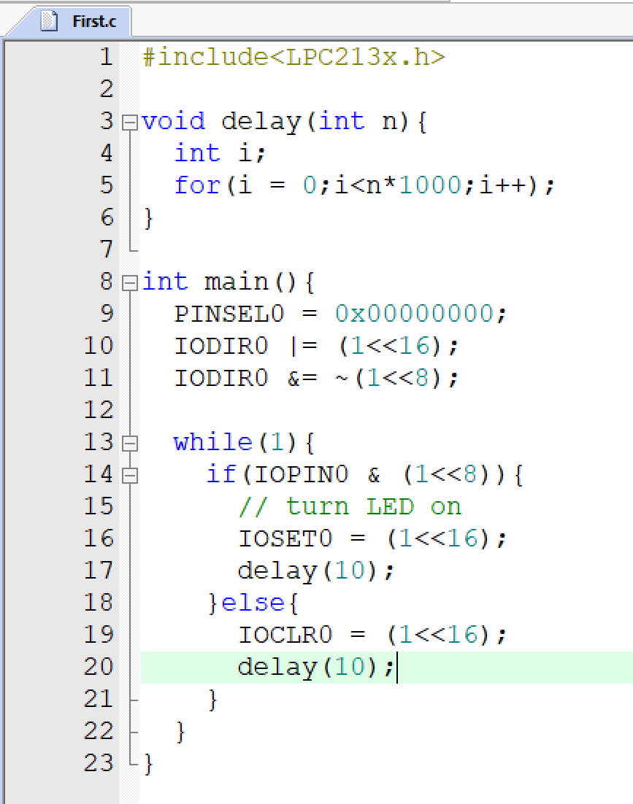

OUTPUT:
